MODULE 3: ENSEMBLE LEARNING

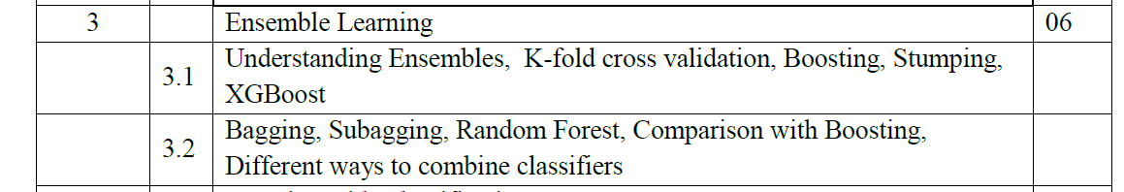
Ensemble learning is a method where we use many small models instead of just one. Each of these models may not be very strong on its own, but when we put their results together, we get a better and more accurate answer. It's like asking a group of people for advice instead of just one person—each one might be a little wrong, but together, they usually give a better answer.

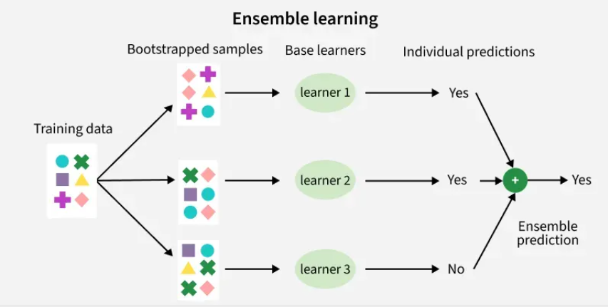

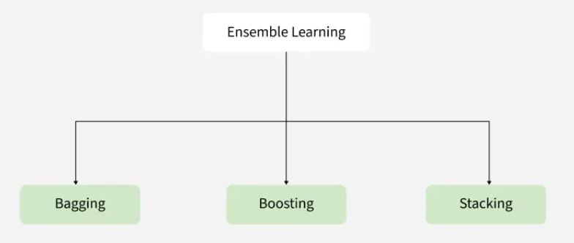
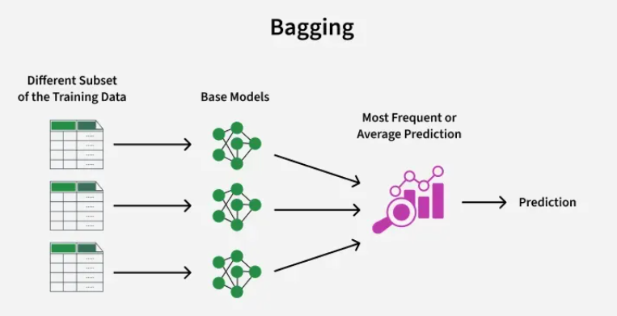

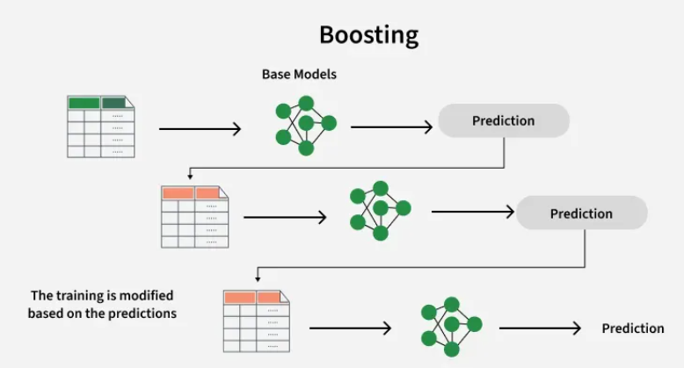

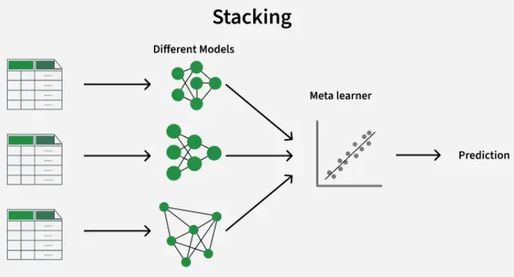

Types of Ensembles Learning in Machine Learning
There are three main types of ensemble methods:
- Bagging (Bootstrap Aggregating):
Models are trained independently on different random subsets of the training data. Their results are then combined—usually by averaging (for regression) or voting (for classification). This helps reduce variance and prevents overfitting.
- Boosting:
Models are trained one after another. Each new model focuses on fixing the errors made by the previous ones. The final prediction is a weighted combination of all models, which helps reduce bias and improve accuracy.
- Stacking (Stacked Generalization):
Multiple different models (often of different types) are trained, and their predictions are used as inputs to a final model, called a meta-model. The meta-model learns how to best combine the predictions of the base models, aiming for better performance than any individual model.

1. Bagging Algorithm
Bagging classifier can be used for both regression and classification tasks. Here is an overview of Bagging classifier algorithm:
- Bootstrap Sampling: Divides the original training data into ‘N’ subsets and randomly selects a subset with replacement in some rows from other subsets. This step ensures that the base models are trained on diverse subsets of the data and there is no class imbalance.
- Base Model Training: For each bootstrapped sample we train a base model independently on that subset of data. These weak models are trained in parallel to increase computational efficiency and reduce time consumption. We can use different base learners i.e. different ML models as base learners to bring variety and robustness.
- Prediction Aggregation: To make a prediction on testing data combine the predictions of all base models. For classification tasks it can include majority voting or weighted majority while for regression it involves averaging the predictions.
- Out-of-Bag (OOB) Evaluation: Some samples are excluded from the training subset of particular base models during the bootstrapping method. These “out-of-bag” samples can be used to estimate the model’s performance without the need for cross-validation.
- Final Prediction: After aggregating the predictions from all the base models, Bagging produces a final prediction for each instance.

2. Boosting Algorithm
Boosting is an ensemble technique that combines multiple weak learners to create a strong learner. Weak models are trained in series such that each next model tries to correct errors of the previous model until the entire training dataset is predicted correctly. One of the most well-known boosting algorithms is AdaBoost (Adaptive Boosting). Here is an overview of Boosting algorithm:
- Initialize Model Weights: Begin with a single weak learner and assign equal weights to all training examples.
- Train Weak Learner: Train weak learners on these dataset.
- Sequential Learning: Boosting works by training models sequentially where each model focuses on correcting the errors of its predecessor. Boosting typically uses a single type of weak learner like decision trees.
- Weight Adjustment: Boosting assigns weights to training datapoints. Misclassified examples receive higher weights in the next iteration so that next models pay more attention to them.

Benefits of Ensemble Learning in Machine Learning
Ensemble learning is a versatile approach that can be applied to machine learning model for: -
- Reduction in Overfitting: By aggregating predictions of multiple model's ensembles can reduce overfitting that individual complex models might exhibit.
- Improved Generalization: It generalizes better to unseen data by minimizing variance and bias.
- Increased Accuracy: Combining multiple models gives higher predictive accuracy.
- Robustness to Noise: It mitigates the effect of noisy or incorrect data points by averaging out predictions from diverse models.
- Flexibility: It can work with diverse models including decision trees, neural networks and support vector machines making them highly adaptable.
- Bias-Variance Tradeoff: Techniques like bagging reduce variance, while boosting reduces bias leading to better overall performance.
There are various ensemble learning techniques we can use as each one of them has their own pros and cons.

Ensemble Learning Techniques
Technique | Category | Description
Random Forest | Bagging | Random forest constructs multiple decision trees on bootstrapped subsets of the data and aggregates their predictions for final output, reducing overfitting and variance.
Random Subspace Method | Bagging | Trains models on random subsets of input features to enhance diversity and improve generalization while reducing overfitting.
Gradient Boosting Machines (GBM) | Boosting | Gradient Boosting Machines sequentially builds decision trees, with each tree correcting errors of the previous ones, enhancing predictive accuracy iteratively.
Extreme Gradient Boosting (XGBoost) | Boosting | XGBoost do optimizations like tree pruning, regularization, and parallel processing for robust and efficient predictive models.
AdaBoost (Adaptive Boosting) | Boosting | AdaBoost focuses on challenging examples by assigning weights to data points. Combines weak classifiers with weighted voting for final predictions.
CatBoost | Boosting | CatBoost specialize in handling categorical features natively without extensive preprocessing with high predictive accuracy and automatic overfitting handling.

What is Bagging classifier?
Bagging or Bootstrap aggregating is a type of ensemble learning in which multiple base models are trained independently and parallelly on different subsets of training data. Each subset is generated using bootstrap sampling in which data points are picked at randomly with replacement. In bagging classifier the final prediction is made by aggregating the predictions of all base model using majority voting. In the models of regression the final prediction is made by averaging the predictions of the all base model and that is known as bagging regression.
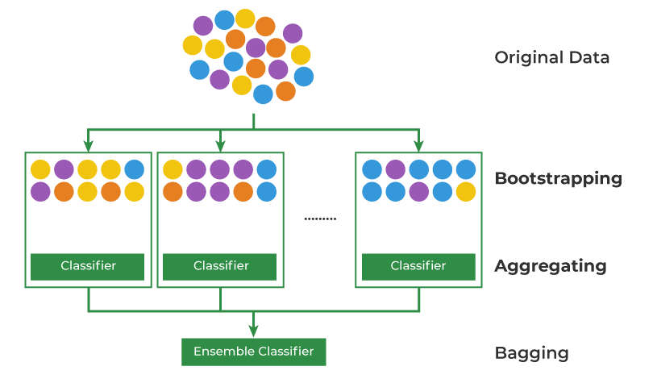
Starting with an original dataset containing multiple data points (represented by colored circles). The original dataset is randomly sampled with replacement multiple times. This means that in each sample, a data point can be selected more than once or not at all. These samples create multiple subsets of the original data.
- For each of the bootstrapped subsets, a separate classifier (e.g., decision tree, logistic regression) is trained.
- The predictions from all the individual classifiers are combined to form a final prediction. This is often done through a majority vote (for classification) or averaging (for regression).
Bagging helps improve accuracy and reduce overfitting especially in models that have high variance.

How does Bagging Classifier Work?
- Bootstrap Sampling: In Bootstrap Sampling data are sampled with 'n' subsets are made randomly from original training dataset with replacement. This step ensures that the base models are trained on diverse subsets of the data as some samples may appear multiple times in the new subset while others may be left out. It reduces the risks of overfitting and improves the accuracy of the model.

Let's break it down step by step:
Original training dataset: [1, 2, 3, 4, 5, 6, 7, 8, 9, 10]
Resampled training set 1: [2, 3, 3, 5, 6, 1, 8, 10, 9, 1]
Resampled training set 2: [1, 1, 5, 6, 3, 8, 9, 10, 2, 7]
Resampled training set 3: [1, 5, 8, 9, 2, 10, 9, 7, 5, 4]
- Base Model Training: In bagging multiple base models are used. After the Bootstrap Sampling each base model is independently trained using learning algorithm such as decision trees, support vector machines or neural networks on a different bootstrapped subset data. These models are typically called "Weak learners" because they are not highly accurate. Since the base model is trained independently and parallelly it makes it computationally efficient and time saving.
- Aggregation: Once all the base models are trained and makes predictions on new unseen data then bagging classifier predicts class label for given instance by majority voting from all base learners. The class which has the majority voting is the prediction of the model.
- Out-of-Bag (OOB) Evaluation: Some samples are excluded from the training subset of particular base models during the bootstrapping method. These "out-of-bag" samples can be used to estimate the model's performance without the need for cross-validation.

Bagging Classifier process begins with the original training dataset which is used to create bootstrap samples (random subsets with replacement) for training multiple weak learners ensuring diversity. Each weak learner independently predicts outcomes as shown in the Base Model Training graph capturing different patterns. These predictions are aggregated using majority voting where the final classification is determined by the maximum voted output. The Out-of-Bag (OOB) evaluates models performance on data excluded from each bootstrap sample for validation. This approach enhances accuracy and reduces overfitting.

Advantages of Bagging Classifier
- Improved Predictive Performance: It outperforms single classifiers by reducing overfitting and increasing predictive accuracy by combining multiple base models.
- Robustness: Reduces the impact of outliers and noise in data by aggregating predictions from multiple models. This enhances the overall stability and robustness of the model.
- Reduced Variance: Since each base model is trained on different subsets of the data the aggregated model's variance is significantly reduced compared to individual model.
- Parallel Working: Bagging allows parallel processing as each base model can be trained independently in parallel. This makes it computationally efficient for large datasets.
- Flexibility: It can be applied to wide range of machine learning algorithms such as decision trees, random forests and support vector machines.

Disadvantages of Bagging:
- Loss of Interpretability: It involves aggregating predictions from multiple models making it harder to interpret individual base model.
- Computationally Expensive: As the number of iterations of bootstrap samples increases, computational cost of bagging also increase.

Applications of Bagging Classifier
- Fraud Detection: It can be used to detect fraudulent transactions by aggregating predictions from multiple fraud detection models.
- Spam filtering: It can be used to filter spam emails by aggregating predictions from multiple spam filters trained on different subsets of the spam emails.
- Credit scoring: Can be used to improve the accuracy of credit scoring models by combining multiple models.
- Image Classification: It can be used to improve the accuracy of image classification task.
- Natural language processing: In NLP tasks it can combine predictions from multiple language models to achieve better text classification results.
Bagging Classifier is an ensemble learning technique that improve model prediction and robustness. It helps avoiding overfitting, improves generalization and gives better predictions by using combining multiple base models and can be used for wide range of applications.

Boosting in Machine Learning | Boosting and AdaBoost

Boosting is an ensemble learning technique that sequentially combines multiple weak classifiers to create a strong classifier. It is done by training a model using training data and is then evaluated. Next model is built on that which tries to correct the errors present in the first model. This procedure is continued and models are added until either the complete training data set is predicted correctly or predefined number of iterations is reached.
Think of it like in a class a teacher focuses more on weak learners to improve its academic performance similarly boosting works.

Adaboost and its working
AdaBoost (Adaptive Boosting) is a boosting technique that assigns equal weights to all training samples initially and iteratively adjusts these weights by focusing more on misclassified datapoints for next model. It effectively reduces bias and variance making it useful for classification tasks but it can be sensitive to noisy data and outliers.
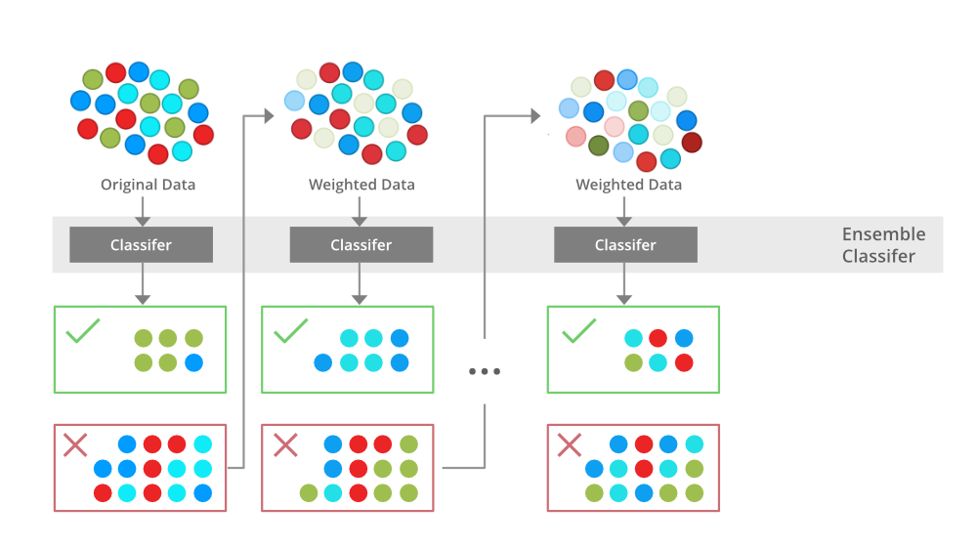Training a boosting model

The above diagram explains the AdaBoost algorithm in a very simple way. Let’s try to understand it in a stepwise process:

Step 1: Initial Model (B1)
- The dataset consists of multiple data points (red, blue and green circles).
- Equal weight is assigned to each data point.
- The first weak classifier attempts to create a decision boundary.
- 8 data points are wrongly classified.

Step 2: Adjusting Weights (B2)
- The misclassified points from B1 are assigned higher weights (shown as darker points in the next step).
- A new classifier is trained with a refined decision boundary focusing more on the previously misclassified points.
- Some previously misclassified points are now correctly classified.
- 6 data points are wrongly classified.

Step 3: Further Adjustment (B3)
- The newly misclassified points from B2 receive higher weights to ensure better classification.
- The classifier adjusts again using an improved decision boundary and 4 data points remain misclassified.

Step 4: Final Strong Model (B4 - Ensemble Model)
- The final ensemble classifier combines B1, B2 and B3 to get strengths of all weak classifiers.
- By aggregating multiple models the ensemble model achieves higher accuracy than any individual weak model.
Now that we have learned how boosting works using Adaboost now we will learn more about different types of boosting algorithms.

Types of Boosting Algorithms
There are several types of boosting algorithms some of the most famous and useful models are as :
- Gradient Boosting: Gradient Boosting constructs models in a sequential manner where each weak learner minimizes the residual error of the previous one using gradient descent. Instead of adjusting sample weights like AdaBoost Gradient Boosting reduces error directly by optimizing a loss function.
- XGBoost: XGBoost is an optimized version of Gradient Boosting that uses regularization to prevent overfitting. It is faster, efficient and supports handling both numerical and categorical variables.
- CatBoost: CatBoost is particularly effective for datasets with categorical features. It employs symmetric decision trees and a unique encoding method that considers target values, making it superior in handling categorical data without preprocessing.

Boosting vs Bagging
Bagging is another ensemble learning technique used to improve accuracy. Unlike bagging where models are trained independently on different machine learning models, Boosting models are trained sequentially with each model correcting the errors of its predecessor.

Here is an in depth difference between them:

Feature | Boosting | Bagging
Combination Type | Combines predictions of different weak models | Combines predictions of the same type of model
Goal | Reduces bias | Reduces variance
Model Dependency | New models depend on previous models' errors | All the models have the same weightage
Weighting | Models are weighted based on performance | All models have equal weight.
Training Data Sampling | Each new model focuses more on the misclassified examples | Each model is trained on random subset of data
Error handling | Focuses on correcting errors made by previous models | Averages out errors from multiple models
Parallelism | Models are built sequentially less parallelizable | Models can be built in parallel
Overfitting | Less prone to overfitting with proper regularization | Can be prone to overfitting with complex base models
Model Complexity | Typically uses simpler models (like decision stumps) | Can use complex models (like full decision trees)
Example | AdaBoost, Gradient Boosting, XGBoost, LightGBM | Random Forest, Bagged Decision Trees

Advantages of Boosting

- Improved Accuracy: By combining multiple weak learners it enhances predictive accuracy for both classification and regression tasks.
- Robustness to Overfitting: Unlike traditional models it dynamically adjusts weights to prevent overfitting.
- Handles Imbalanced Data Well: It prioritizes misclassified points making it effective for imbalanced datasets.
- Better Interpretability: The sequential nature of helps break down decision-making making the model more interpretable.

Random Forest Algorithm in Machine Learning

Random Forest is a machine learning algorithm that uses many decision trees to make better predictions. Each tree looks at different random parts of the data and their results are combined by voting for classification or averaging for regression. This helps in improving accuracy and reducing errors.
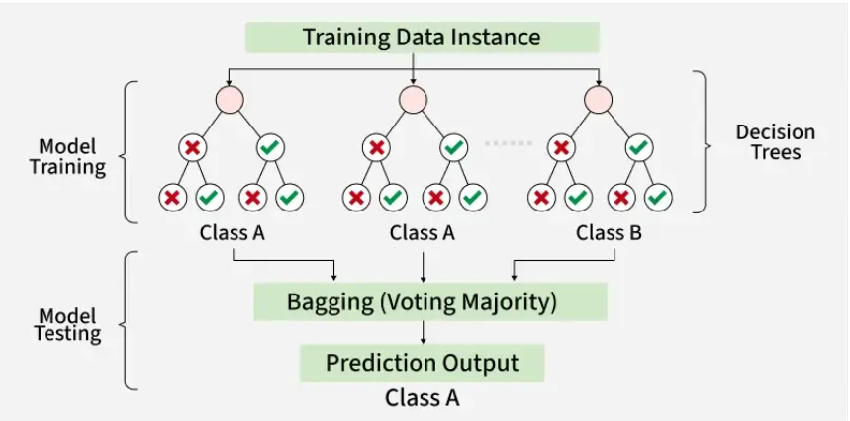
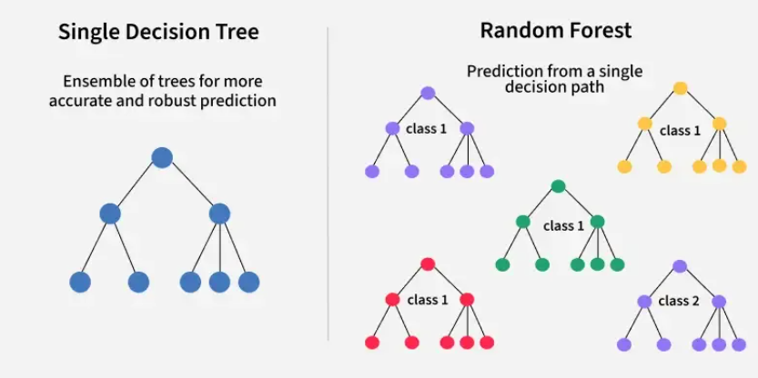

Working of Random Forest Algorithm

- Create Many Decision Trees: The algorithm makes many decision trees each using a random part of the data. So every tree is a bit different.
- Pick Random Features: When building each tree it doesn’t look at all the features (columns) at once. It picks a few at random to decide how to split the data. This helps the trees stay different from each other.
- Each Tree Makes a Prediction: Every tree gives its own answer or prediction based on what it learned from its part of the data.
- Combine the Predictions:
  - For classification we choose a category as the final answer is the one that most trees agree on i.e majority voting.
  - For regression we predict a number as the final answer is the average of all the trees predictions.
- Why It Works Well: Using random data and features for each tree helps avoid overfitting and makes the overall prediction more accurate and trustworthy.

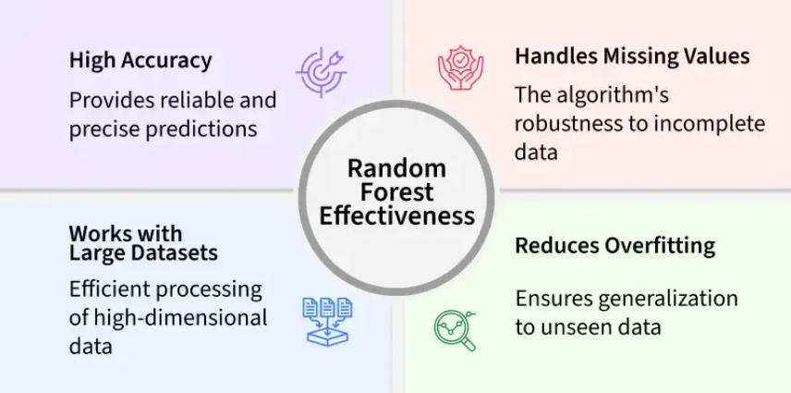

Key Features of Random Forest
- Handles Missing Data: It can work even if some data is missing so you don’t always need to fill in the gaps yourself.
- Shows Feature Importance: It tells you which features (columns) are most useful for making predictions which helps you understand your data better.
- Works Well with Big and Complex Data: It can handle large datasets with many features without slowing down or losing accuracy.
- Used for Different Tasks: You can use it for both classification like predicting types or labels and regression like predicting numbers or amounts.

Assumptions of Random Forest
- Each tree makes its own decisions: Every tree in the forest makes its own predictions without relying on others.
- Random parts of the data are used: Each tree is built using random samples and features to reduce mistakes.
- Enough data is needed: Sufficient data ensures the trees are different and learn unique patterns and variety.
- Different predictions improve accuracy: Combining the predictions from different trees leads to a more accurate final result.

Advantages of Random Forest
- Random Forest provides very accurate predictions even with large datasets.
- Random Forest can handle missing data well without compromising with accuracy.
- It doesn’t require normalization or standardization on dataset.
- When we combine multiple decision trees it reduces the risk of overfitting of the model.

Limitations of Random Forest
- It can be computationally expensive especially with a large number of trees.
- It’s harder to interpret the model compared to simpler models like decision trees.

Gradient Boosting in ML

Gradient Boosting is a ensemble learning method used for classification and regression tasks. It is a boosting algorithm which combine multiple weak learner to create a strong predictive model. It works by sequentially training models where each new model tries to correct the errors made by its predecessor.
In gradient boosting each new model is trained to minimize the loss function such as mean squared error or cross-entropy of the previous model using gradient descent. In each iteration the algorithm computes the gradient of the loss function with respect to predictions and then trains a new weak model to minimize this gradient. Predictions of the new model are then added to the ensemble (all models prediction) and the process is repeated until a stopping criterion is met.

Shrinkage and Model Complexity

A key feature of Gradient Boosting is shrinkage which scales the contribution of each new model using learning rate (denoted as ηη).
- Smaller learning rates: mean the contribution of each tree is smaller which reduces the risk of overfitting but requires more trees to achieve the same performance.
- Larger learning rates: mean each tree has a more significant impact but this can lead to overfitting.

There's a trade off between the learning rate and the number of estimators (trees) a smaller learning rate usually means more trees are required to achieve optimal performance.

Working of Gradient Boosting

1. Sequential Learning Process
The ensemble consists of multiple trees each trained to correct the errors of the previous one. In the first iteration Tree 1 is trained on the original data xx and the true labels yy. It makes predictions which are used to compute the errors.

2. Residuals Calculation
In the second iteration Tree 2 is trained using the feature matrix xx and the errors from Tree 1 as labels. This means Tree 2 is trained to predict the errors of Tree 1. This process continues for all the trees in the ensemble. Each subsequent tree is trained to predict the errors of the previous tree.
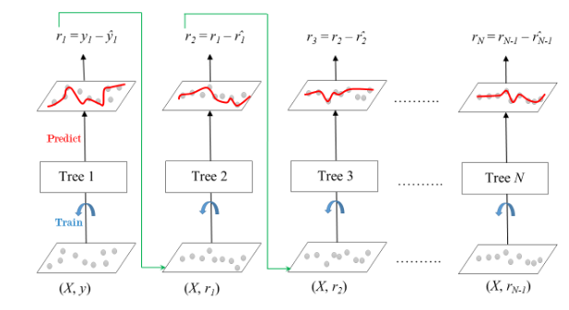

Gradient Boosted Trees

3. Shrinkage
After each tree is trained its predictions are shrunk by multiplying them with the learning rate η which ranges from 0 to 1. This prevents overfitting by ensuring each tree has a smaller impact on the final model.
Once all trees are trained predictions are made by summing the contributions of all the trees. The final prediction is given by the formula:
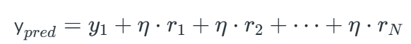
Where r1​,r2​,…,rN​ are the errors predicted by each tree.

Difference between Adaboost and Gradient Boosting
The difference between AdaBoost and gradient boosting are as follows:

Features | AdaBoost | Gradient Boosting
Weight Update Strategy | Increase weights of misclassified sample so that the next learner focuses more on them. | Updates predictions by minimizing a loss function using the negative gradient
Base learners | AdaBoost uses simple decision trees with one split known as the decision stumps of weak learners. | Gradient Boosting can use a wide range of base learners such as decision trees and linear models.
Sensitivity to Noise | AdaBoost is more sensitive to noisy data and outliers due to aggressive weighting. | Gradient Boosting is less sensitive as it smooths updates using gradients.
Optimization Technique | No explicit loss function i.e it focuses on classification error. | Explicitly minimizes a differentiable loss function.
Boosting Mechanism | Learners are trained sequentially with sample reweighting. | Learners are trained sequentially with residual fitting (gradient descent).
Interpretability | Easier to interpret due to simple weak learners. | Harder to interpret if complex models are used.
Use case | Suitable for clean datasets with fewer outliers | Suitable for complex problems with varying loss function

Gradient Boosting is an effective and widely-used machine learning technique for both classification and regression problems. It builds models sequentially focusing on correcting errors made by previous models which leads to improved performance.

XGBoost

Traditional machine learning models like decision trees and random forests are easy to interpret but often struggle with accuracy on complex datasets. XGBoost short form for eXtreme Gradient Boosting is an advanced machine learning algorithm designed for efficiency, speed and high performance.
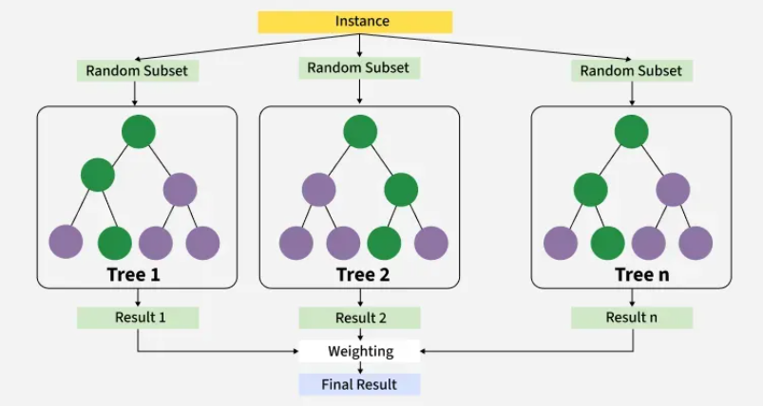
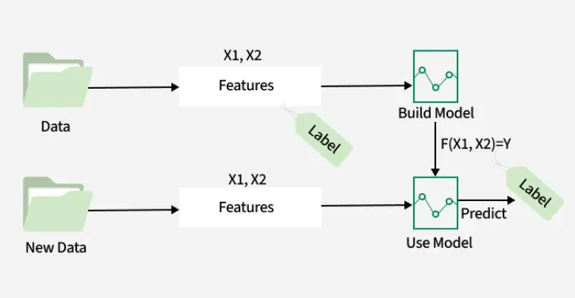
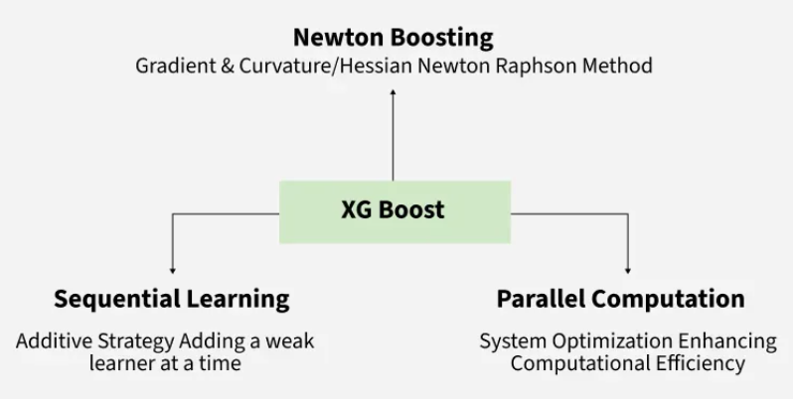

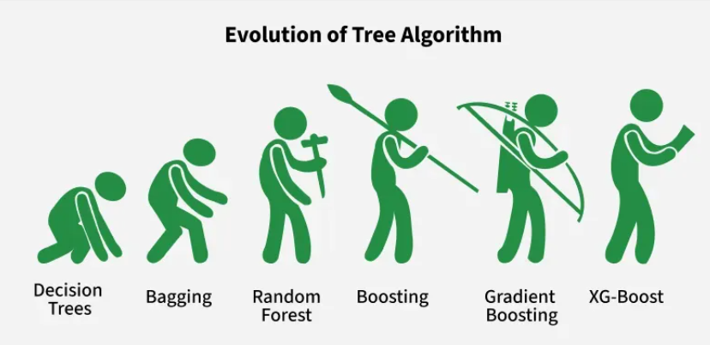
It is an optimized implementation of Gradient Boosting and is a type of ensemble learning method that combines multiple weak models to form a stronger model.
- XGBoost uses decision trees as its base learners and combines them sequentially to improve the model’s performance. Each new tree is trained to correct the errors made by the previous tree and this process is called boosting.
- It has built-in parallel processing to train models on large datasets quickly. XGBoost also supports customizations allowing users to adjust model parameters to optimize performance based on the specific problem.

How XGBoost Works?

It builds decision trees sequentially with each tree attempting to correct the mistakes made by the previous one. The process can be broken down as follows:
- Start with a base learner: The first model decision tree is trained on the data. In regression tasks this base model simply predicts the average of the target variable.
- Calculate the errors: After training the first tree the errors between the predicted and actual values are calculated.
- Train the next tree: The next tree is trained on the errors of the previous tree. This step attempts to correct the errors made by the first tree.
- Repeat the process: This process continues with each new tree trying to correct the errors of the previous trees until a stopping criterion is met.
- Combine the predictions: The final prediction is the sum of the predictions from all the trees.

Mathematics behind XGBoost Algorithm
It can be viewed as iterative process where we start with an initial prediction often set to zero. After which each tree is added to reduce errors. Mathematically the model can be represented as:

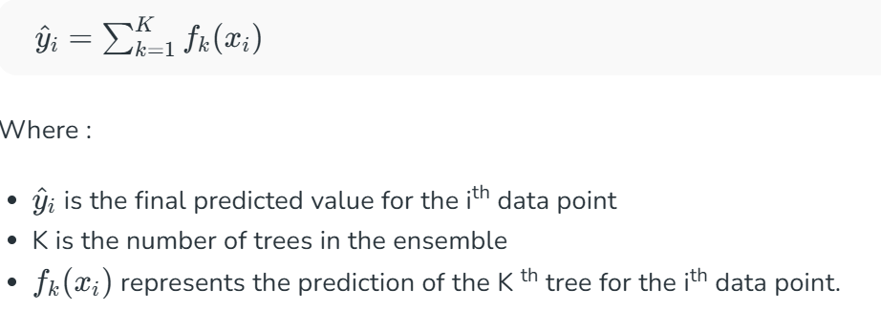
The objective function in XGBoost consists of two parts: a loss function and a regularization term. The loss function measures how well the model fits the data and the regularization term simplify complex trees. The general form of the loss function is:
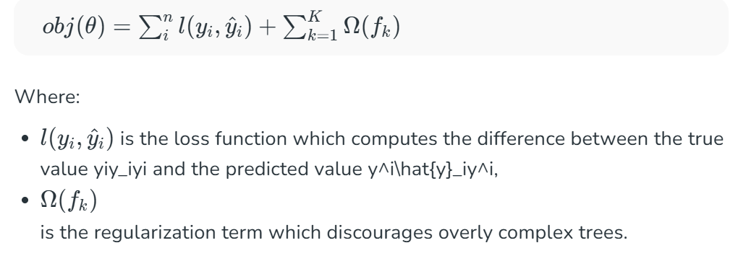
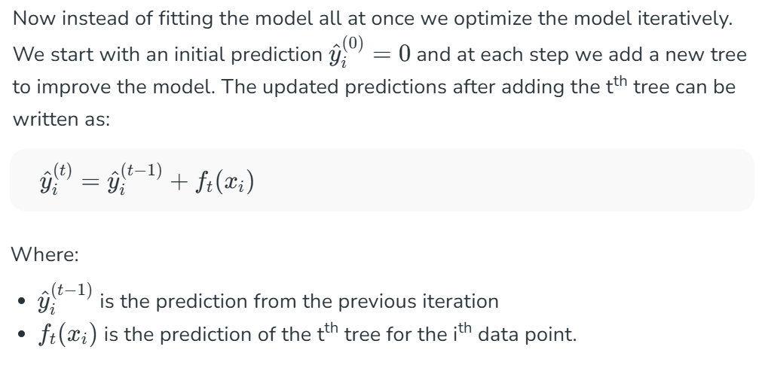
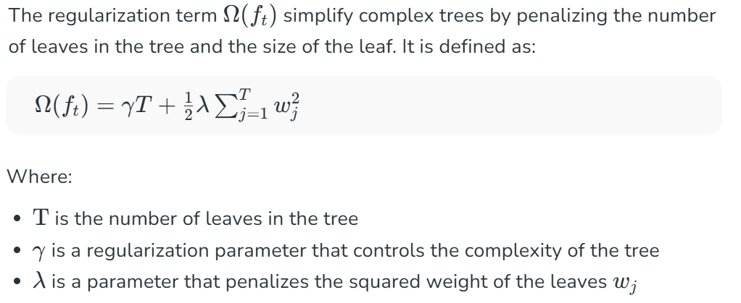

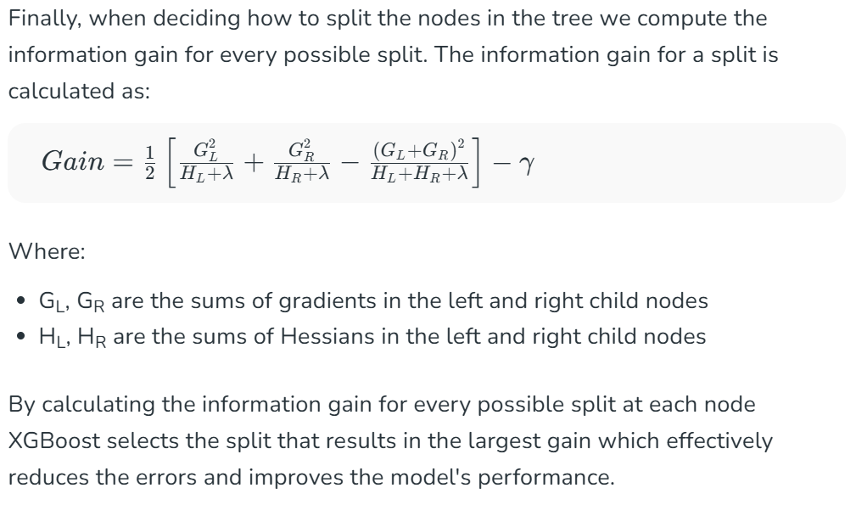

What Makes XGBoost "eXtreme"?

XGBoost extends traditional gradient boosting by including regularization elements in the objective function, XGBoost improves generalization and prevents overfitting.

1. Preventing Overfitting
- Learning rate (eta) controls each tree's contribution to the final prediction
- Lower learning rate makes the model more conservative and resilient
- Helps reduce overfitting when combined with regularization
- XGBoost grows trees level by level (depth-wise)
- At each level it checks if a new split improves the objective function
- Splits that don't improve the model are trimmed (pruned)
- This makes trees simpler and faster to build
- Regularization, shrinkage (learning rate) and pruning help prevent overfitting
- These techniques improve generalization and model robustness

2. Tree Structure
Conventional decision trees are frequently developed by expanding each branch until a stopping condition is satisfied or in a depth-first fashion. On the other hand, XGBoost builds trees level-wise or breadth-first. This implies that it adds nodes for every feature at a certain depth before moving on to the next level, so growing the tree one level at a time.
- Determining the Best Splits: XGBoost assesses every split that might be made for every feature at every level and chooses the one that minimizes the objective function as much as feasible like minimizing the mean squared error for regression tasks or cross-entropy for classification tasks.
In contrast, a single feature is selected for a split at each level in depth-wise expansion.
- Prioritizing Important Features: The overhead involved in choosing the best split for each feature at each level is decreased by level-wise growth. XGBoost eliminates the need to revisit and assess the same feature more than once during tree construction because all features are taken into account at the same time.
This is particularly beneficial when there are complex interactions among features as the algorithm can adapt to the intricacies of the data.

3. Handling Missing Data
- XGBoost handles missing data effectively during training
- Uses Sparsity Aware Split Finding algorithm
- Treats missing values as a separate category during split evaluation
- During tree building, missing values follow a default direction at each split
- Algorithm calculates gain for splits, considering missing values as a separate group
- For prediction if a feature is missing then instance follows the default branch
- This ensures robust predictions even with incomplete input data

4. Cache-Aware Access in XGBoost
- Cache memory is faster and located close to the CPU
- Modern systems use hierarchical memory for better performance
- XGBoost uses cache-aware access to reduce memory access time
- Frequently accessed data is stored in CPU cache during training
- Uses spatial locality: nearby data in memory is accessed together
- Data is arranged in a cache-friendly way to speed up computation
- Reduces reliance on slower main memory, improving training speed

5. Approximate Greedy Algorithm
- Uses weighted quantiles to find optimal splits quickly
- Avoids checking every possible split in detail
- Approximates best split to improve speed and scalability
- Ideal for large datasets where full split evaluation is costly
- Reduces computational overhead while maintaining accuracy

Advantages of XGboost
- Scalable and efficient for large datasets with millions of records
- Supports parallel processing and GPU acceleration for faster training
- Offers customizable parameters and regularization for fine-tuning
- Includes feature importance analysis for better insights and selection
- Trusted by data scientists across multiple programming languages

Disadvantages of XGBoost
- XGBoost can be computationally intensive, making it less ideal for resource-constrained systems.
- It may be sensitive to noise or outliers, requiring careful data preprocessing.
- Prone to overfitting, especially on small datasets or with too many trees.
- Offers feature importance, but overall model interpretability is limited compared to simpler methods which is an issue in fields like healthcare or finance.

CatBoost in Machine Learning

When working with machine learning we often deal with datasets that include categorical data. We use techniques like One-Hot Encoding or Label Encoding to convert these categorical features into numerical values. However One-Hot Encoding can lead to sparse matrix and cause overfitting. This is where CatBoost helps as it automatically handles everything hence improving model performance without the need for extra preprocessing.

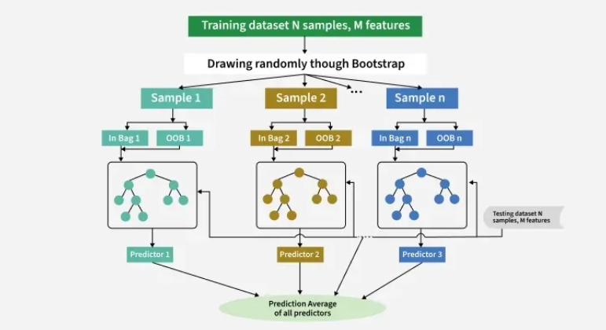
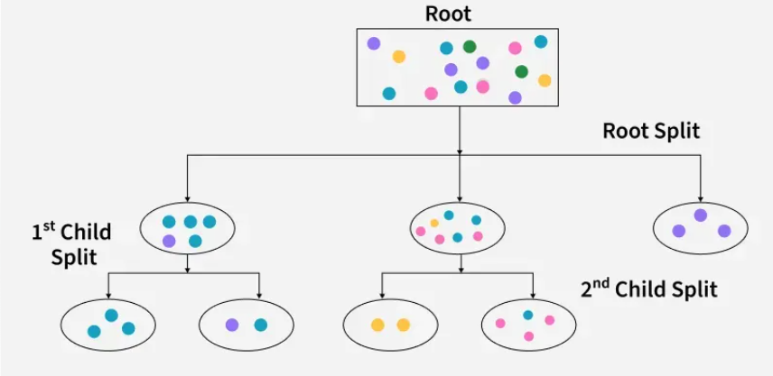

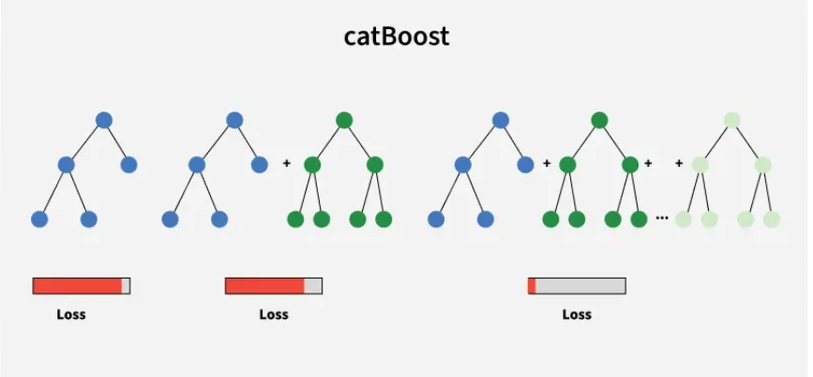

Working of Catboost
Catboost (categorical boosting) is based on the concept of gradient boosting technique where decision trees are built sequentially to minimize errors and improve predictions. The process works by constructing a decision tree and evaluating how much error are there in predictions. Once the first tree is built the next tree is created to correct the errors made by the previous one. This process continues iteratively with each new tree focusing on improving the model’s predictions by reducing previous errors this process continue till a predefined number of iterations met. The result is a ensemble of decision trees that work together to provide accurate predictions.
It is particularly well-suited for large-scale datasets with many independent features. Unlike other gradient boosting algorithms CatBoost is specifically designed to handle both categorical and numerical features seamlessly without requiring manual feature encoding.

Features of CatBoost

Here are some key features due to which CatBoost is widely used in machine learning:

1. Handling Categorical Features with CatBoost:
It efficiently handles categorical features into numerical features without requiring preprocessing. It encodes categorical features using target and one-hot encoding strategies internally.

2. Handling Missing Values with CatBoost:
Unlike other Models CatBoost can handle missing values in the input data without requiring imputation. The Symmetric Weighted Quantile Sketch (SWQS) algorithm in it handles missing data efficiently by reducing overfitting and improving model performance.

3. Model Training and Analysis:
CatBoost supports GPU-accelerated training which helps speed up the model-building process especially when working with large datasets. This allows models to be trained faster by using the power of graphics cards (GPUs).
It also uses parallel processing techniques to take advantage of multiple CPU cores during training. This makes the training process more efficient and scalable making CatBoost a good choice for complex problems and large-scale machine learning tasks.

4. Catboost Metrics
CatBoost metrics are used to check how well the model is performing. Common metrics include accuracy, precision, recall, F1-score, ROC-AUC for classification and RMSE for regression. These help users understand how good the predictions are and where improvements are needed.
CatBoost also uses smart techniques to avoid overfitting such as ordered boosting, random feature combinations and strong boosting methods. These help the model perform well even on new, unseen data.

CatBoost Applications
Classification Tasks:
- Sentiment analysis
- Email spam detection
- Breast cancer prediction

Regression Tasks:
- House price prediction
- Fuel consumption prediction
- Stock market prediction

Limitations of CatBoost
Despite of the various features or advantages of catboost it has the following limitations:
- Memory Consumption: It may require significant memory resources especially for large datasets.
- Training Time: Training CatBoost models can be computationally intensive particularly with default hyperparameters.
- Hyperparameter Tuning: Finding the optimal set of hyperparameters may require extensive experimentation.
- Distributed Training: Limited built-in support for distributed training across multiple machines.
- Community and Documentation: They have a smaller community and less extensive documentation compared to other popular machine learning libraries.

K- Fold Cross Validation in Machine Learning

K-Fold Cross Validation is a statistical technique to measure the performance of a machine learning model by dividing the dataset into K subsets of equal size (folds). The model is trained on K − 1 folds and tested on the last fold. This process is repeated K times, with each fold being used as the testing set exactly once. The performance of the model is then averaged over all K iterations to provide a robust estimate of its generalization ability.

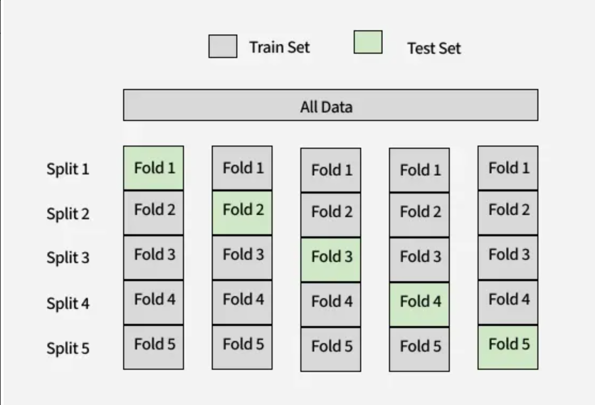 K - Fold train and test split

What is Cross Validation
Cross-validation serves multiple purposes:
- Avoids Overfitting: Ensures that the model does not perform well only on the training data but generalizes to unseen data.
- Provides Robust Evaluation: Averages results over multiple iterations, reducing bias and variance in the performance metrics.
- Efficient Use of Data: Maximizes the utilization of the dataset, especially when the data size is limited.

K-Fold Cross Validation
The process can be broken into the following steps:
1. Split Data into K Folds: Divide the dataset into K subsets or folds.
2. Train-Test Iterations: For each fold:
- Use K −1 folds for training the model.
- Use the remaining fold as the test set to evaluate the model.
3. Aggregate Results: Calculate the performance metric (e.g., accuracy, precision, recall, etc.) for each fold and average the results.
Let 𝐷 be the dataset, split into 𝐾 folds. For each fold 𝑘, the training set is:

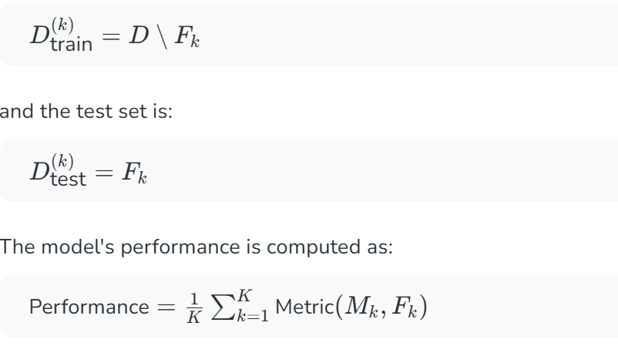

Choosing the Value of K
The choice of K affects the trade-off between bias and variance:
- Small K (e.g., K =2 or K=5): Faster computation with increased variance in performance estimates.
- Large K (e.g., K =10 or K =n, where n is the size of the dataset): Lower variance but higher computational cost. K =n corresponds to Leave-One-Out Cross Validation (LOOCV).
A standard choice is 10-Fold Cross Validation that is a good trade-off between bias and variance in most situations.

Variants of K-Fold Cross Validation

  - Stratified K-Fold Cross Validation: Maintains the same class distribution for each fold as for the entire dataset, particularly helpful for datasets that are imbalanced.
Stratified K-Fold Cross Validation is a technique used for evaluating a model. It is particularly useful for classification problems in which the class labels are not evenly distributed i.e data is imbalanced. It is a enhanced version of K-Fold Cross Validation. Key difference is that it uses stratification which allows original distribution of each class to be maintained across each fold.
For example, if your original dataset had 80% Class 0 and 20% Class 1 your folds would reflect the same proportion of classes in your data. This creates improved and more reliable accuracy metrics.

Problem with Random Splitting
Random splitting techniques like train_test_split() or regular K-Fold can create problem if they produce imbalanced class proportions in the training and test sets. For example imagine a binary classification dataset with 100 samples where:
- 80 samples are Class 0
- 20 samples are Class 1
Using random sampling in an 80:20 split then all 80 Class 0 in the training set and all 20 Class 1 in the test set. In this case model will never learn to classify Class 1 and would give misleading accuracy.
Now, let’s use stratified sampling on same dataset:
1. Training Set (80 samples):
- 64 from Class 0 (80% of 80)
- 16 from Class 1 (80% of 20)
2. Test Set (20 samples):
- 16 from Class 0 (20% of 80)
- 4 from Class 1 (20% of 20)
This ensures that both training and test sets provide an accurate representation of the full dataset's class proportions and better generalization in the evaluation set.
In real-world classification tasks distribution of observations per class is often imbalanced like in a medical dataset it could be the case that 90% of patients are healthy (Class 0) and 10% have a disease (Class 1). If we randomly split this data there may be some training/test sets that have very few sample or even no samples for the minority class that where Stratified K Fold Cross Validation becomes important.
By using Stratified K-Fold Cross Validation we can ensure that our machine learning model is evaluated fairly and consistently leading to more accurate predictions and better real-world performance.

  - Repeated K-Fold Cross Validation: Performs the K-Fold operation several times with varying splits, giving more stable performance estimates.
Repeated K-Fold Cross-Validation is a method used to evaluate machine learning models for both classification and regression tasks. It involves splitting the dataset into K equal parts, training the model on K−1 parts and testing it on the remaining part. This process is repeated K times so that each part is used once as a test set. The entire K-Fold process is then repeated multiple times with different random splits of the data. This helps provide a more reliable and consistent estimate of the model’s performance by reducing the impact of any single data split.

Steps in Repeated K-Fold Cross-Validation
- Randomly split the dataset into K equal subsets.
- Select one subset as the validation set.
- Use the remaining K−1 subsets to train the model.
- Evaluate the model on the validation set and calculate prediction error.
- Repeat steps 2–4 until each subset has been used once as the validation set.
- Calculate the average of all K prediction errors.
- Repeat steps 1–6 for a fixed number of repetitions with a new random split each time.
- Calculate the final model performance as the average of all repetition results.

Advantages of Repeated K-fold cross-validation
- A very effective method to estimate the prediction error and the accuracy of a model.
- In each repetition, the data sample is shuffled which results in developing different splits of the sample data.

Disadvantages of Repeated K-fold cross-validation
- A lower value of K leads to a biased model and a higher value of K can lead to variability in the performance metrics of the model. Thus, it is essential to use the correct value of K for the model(generally K = 5 and K = 10 is desirable).
- With each repetition, the algorithm has to train the model from scratch which means the computation time to evaluate the model increases by the times of repetition.
  - Leave-One-Out Cross Validation (LOOCV): A special case where K is equal to the number of data points, so every fold will hold one data point.

LOOCV (Leave-One-Out Cross-Validation) is a model evaluation technique used to assess the performance of a machine learning model on small datasets. In LOOCV, one observation is used as the test set while the rest form the training set. This process is repeated for each data point in the dataset, resulting in n training-testing cycles, where n is the number of observations. The overall accuracy is averaged across all iterations.

Mathematical Expression
In Leave-One-Out Cross-Validation (LOOCV), each individual observation serves once as the validation set, while the remaining n-1 observations are used for training. Instead of refitting the model n times, LOOCV for linear models can be computed efficiently using the following formula:
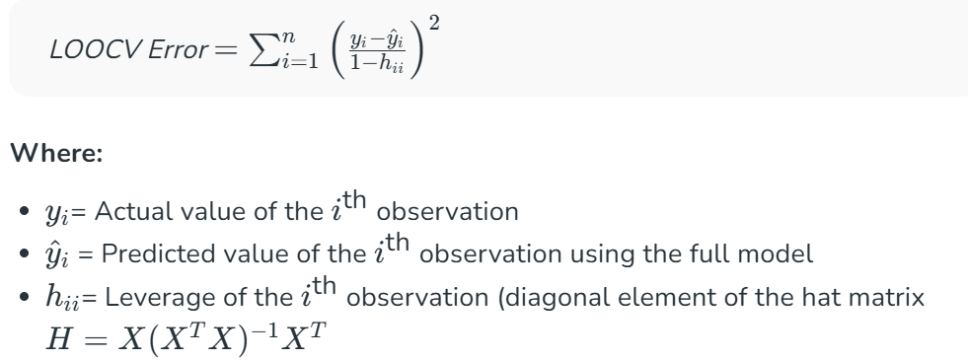

Advantages of LOOCV
- It has no randomness of using some observations for training vs. validation set. In the validation-set method, each observation is considered for both training and validation so it has less variability due to no randomness no matter how many times it runs.
- It has less bias than validation-set method as training-set is of n-1 size. On the entire data set. As a result, there is a reduced over-estimation of test-error as much compared to the validation-set method.
Disadvantage of LOOCV : Training the model N times leads to expensive computation time if the dataset is large.

Benefits of K-Fold Cross Validation

- Efficient Data Usage: Every data point is used for both training and testing.
- Reliable Estimates: Reduces the likelihood of overfitting or underfitting.
- Applicability: Works well with small datasets or when data collection is expensive.
- Time-Series Data: For time-series data, where the order of observations is crucial, a modification called Time Series Cross Validation is used. The training set consists of all data points up to time t, and the test set includes all data points at time t+1 and beyond.

Limitations of K-Fold Cross Validation

- Computational Cost: Re-training the model k times can be time-consuming, especially for large datasets or complex models.
- Data Leakage Risk: Care must be taken to ensure that no data preprocessing (e.g., scaling, encoding) leaks information from the test set into the training set.
- Not Ideal for Time-Series Data: Sequential dependencies in time-series data may render K-Fold inappropriate without modifications like time-based splits.

Differences between Random Forest and AdaBoost

Random Forest Algorithm is a commonly used machine learning algorithm that combines the output of multiple Decision Trees to achieve a single result. It handles both classification and regression problems as it combines the simplicity of decision trees with flexibility leading to significant improvements in accuracy.
AdaBoost Algorithm (Adaptive Boosting), is a Boosting method used as an Ensemble Machine Learning System. The weights of each tree is redistributed in each turn, with higher weights given to incorrectly classified conditions, therefore, it is called Adaptive Boosting. AdaBoost uses multiple single-level decision-making trees called the Forest of Trees.

Difference between Random Forest and AdaBoost

Tree Size
In a random forest, each time you make a tree, you make a full-sized tree. Some trees might be bigger than others, but there is no predetermined maximum depth.
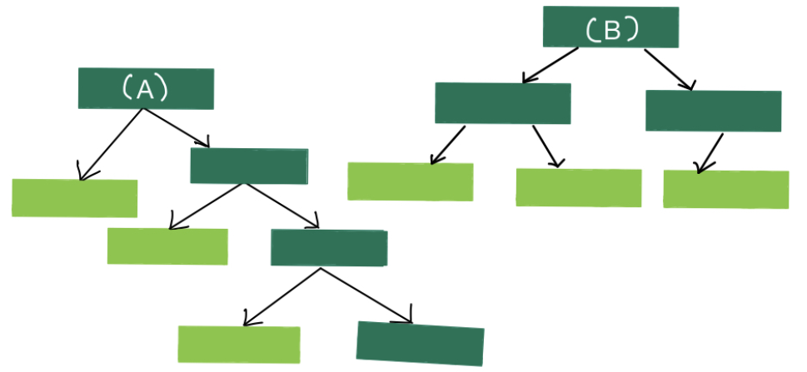
In contrast, in a forest of trees made with AdaBoost, the trees are usually just a node and two leaves. A tree with just one node and two leaves is called a stump, so forest of trees is actually just a Forest of Stumps.
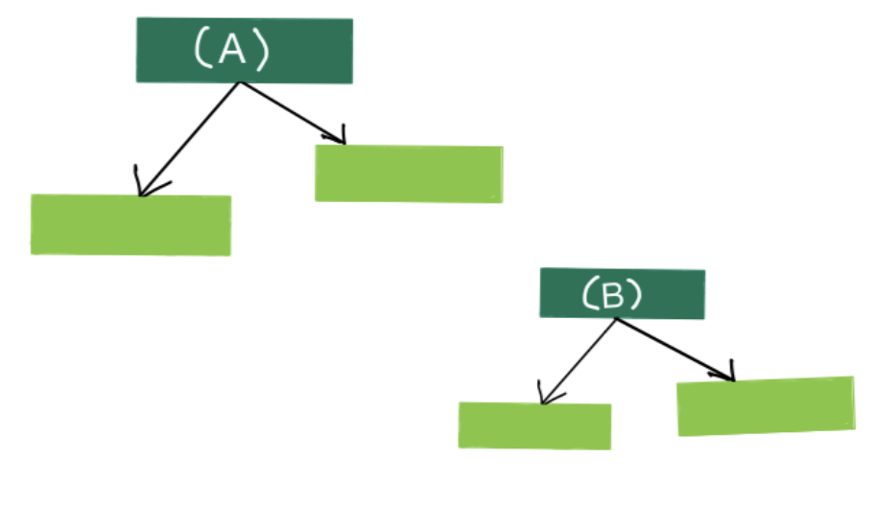

Classification Accuracy
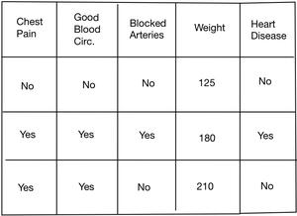Fig. 3 : Data table
Random forest is much better at making accurate classifications. For eg. if we were using the data in fig. 3 to determine if someone had heart disease or not, then a full sized Decision tree would take advantage of all four variables that is measured (Chest Pain, Blood Circulation, Blocked Arteries and Weight) to make a decision.
Stumps are not great at making accurate classifications, since random forest uses all the variables given in the data table but AdaBoost uses only one variable to make a decision therefore, , they are said to be weak learners. For eg. as per fig. 3 forest of trees will use only chest pain to decide whether a person has heart disease or not. However, that's the way AdaBoost likes it, and it's one of the reasons why they are so commonly combined.

Distribution of say for each tree
In a Random Forest, each tree has an equal vote on the final classification. Any tree of any size has the same weightage of vote.
In contrast, in a Forest of Stumps made with AdaBoost, some stumps get more say in the final classification than others. In the diagram, larger stumps get more say than smaller stumps.

Order for constructing trees
In Random Forest, each decision tree is made independently of the others. In other words, it doesn't matter which tree was made at what turn.
On the other hand, in a Forest of Stumps made with AdaBoost, the order is important. The errors that the first stump makes influence how the second stump is made, errors of the second stump influence the third stump and so on.
S. No. | Categories | Random Forest | AdaBoost
1. | Tree Size | Random forest uses a full-sized Decision tree with no predetermined depth size. | AdaBoost combines a lot of "weak learners" to make classifications. The weak learners are almost always stumps.
2. | Distribution of say for each tree. | Each tree has an equal vote on the final classification | Some stumps get more say in the classification than others.
3. | Classification Accuracy | Random Forest often gets outperformed by AdaBoost in terms of classification accuracy. | AdaBoost is often much better at making accurate classifications.
4. | Tree Construction Order | Each decision tree is made independently of the others | Each stump is made by taking the previous stump's mistakes into account.
5. | Overfitting Tolerance | Random Forest is less sensitive to overfitting as compared to AdaBoost | Adaboost is also less tolerant to overfitting than Random Forest.
6. | Data Sampling Technique | In Random forest, the training data is sampled based on the bagging technique. | Adaboost is based on boosting technique.
7. | Estimate Calculation | Random Forest aims to decrease variance not bias. | Adaboost aims to decrease bias, not variance.
8. | Ensembling Operation | Random Forest employs parallel assembly. Forest processes trees in parallel, allowing jobs to be parallelized on a multiprocessor machine. | Adaboost makes use of sequential ensembling. It takes a step-by-step method.

Effectiveness of Ensembles

Ensembles are effective because they address three key challenges in machine learning:

1. Statistical Problem
When the set of possible models is too large for the available data, multiple models can fit the training data well. A learning algorithm might pick just one of them, which may not generalize well. Ensembles reduce this risk by averaging across multiple models.

2. Computational Problem
In cases where algorithms cannot efficiently find the optimal model, ensemble learning mitigates this by combining several approximate solutions.

3. Representational Problem
If the true function is not present in the set of the base learner, ensembles can combine multiple models to better approximate complex target functions.
Note: The main challenge is diversity among the models. For ensembles to be effective, each base model should make different types of errors. Even if individual models are relatively weak, the ensemble can still perform strongly if their mistakes are uncorrelated.

Methods for Constructing Ensemble Models

Ensemble methods can be classified into two main categories based on how the base models are trained and combined.

1. Independent Ensemble Construction
In this approach, each base model is trained separately without relying on the others. Randomness is often introduced during the training process to ensure that the models learn different aspects of the data and make diverse errors. Once trained, their predictions are combined using aggregation techniques such as averaging or voting to produce the final output.

2. Coordinated Ensemble Construction
This approach builds models in a dependent or sequential manner, where each model is influenced by the performance of the previous ones. By focusing on correcting earlier mistakes, the ensemble becomes progressively more accurate. The predictions of these models are then combined in a way that uses their complementary strengths.

Different ways to combine classifiers
Several techniques exist for combining classifiers, each with its own strengths and weaknesses. These methods generally fall under the umbrella of ensemble learning, which aims to improve accuracy, robustness, and generalization by leveraging multiple models. The most common approaches include voting, bagging, boosting, and stacking.
Here's a breakdown of these methods:
1. Voting:
- Simple and widely used:
Voting combines predictions from multiple classifiers by aggregating their individual outputs.
- Types:
  - Hard voting: Each classifier casts a vote for a class, and the class with the majority votes is selected as the final prediction.
  - Soft voting: Instead of just class labels, classifiers provide probability estimates for each class. The final prediction is based on the average probability scores across all classifiers.
- Example:
A simple majority vote among a set of classifiers to classify an image as "cat" or "dog".
2. Bagging (Bootstrap Aggregating):
- Reduces variance and overfitting:
Bagging trains multiple models on different random subsets of the training data (with replacement) and then combines their predictions.
- Parallel training:
Each model can be trained independently, making it suitable for parallel processing.
- Example:
Random Forests, where decision trees are trained on bootstrapped samples of the data.
3. Boosting:
- Sequentially builds strong learners: Boosting trains models one after another, with each new model focusing on correcting the errors made by its predecessors.
- Weight updates: Each data instance is assigned a weight, and these weights are adjusted during training to emphasize misclassified instances.
- Examples: AdaBoost, Gradient Boosting, XGBoost.
4. Stacking (Stacked Generalization):
- Combines diverse learners:
Stacking uses a "meta-learner" to combine the predictions of multiple base-level classifiers.
- Two-stage process:
Base-level models are trained on the original data, and their predictions are used as input features for the meta-learner, which learns to make the final prediction.
- Example:
Training SVM, Naive Bayes, and Decision Tree as base-level classifiers, then using a logistic regression model as the meta-learner.
Other considerations:
- Levels of Combination:
Classifiers can be combined at different levels: sensor data, feature, or decision level.
- Ensemble methods vs. Hybrid methods:
Ensemble methods utilize the same learning technique for all classifiers, while hybrid methods combine different learning techniques.
- Sensor Fusion:
In some applications, sensor data from multiple sources can be combined to improve classification accuracy.
By carefully choosing and combining classifiers, it's often possible to achieve better predictive performance than relying on a single model alone.

***************************************************************************

